PHASE 2 — DATA ARCHITECTURE & CONFIGURATION
Project Title
Car Rental Request Automation in ServiceNow Using Service Catalog and Workflows

1. Introduction
Phase 2 focuses on designing and configuring the data architecture and supporting ServiceNow components required for the Car Rental Request Automation project.
After identifying the business and functional requirements in Phase 1, this phase converts those requirements into a structured ServiceNow design.
The objective is to determine:
- What information needs to be stored
- Where the information should be stored
- What fields are required
- What catalog variables are required
- How requests, approvals, and fulfillment tasks are related
- How vehicle information is represented
- How configuration changes are managed using Update Sets
This phase provides the technical foundation for the Service Catalog and Workflow implementation.

2. Objectives of Phase 2
The main objectives are:
- Design the data architecture for the project.
- Identify the required ServiceNow records and tables.
- Define fields for the car-rental request.
- Define the Service Catalog variables.
- Design the vehicle/car inventory structure.
- Establish relationships between requests and fulfillment records.
- Configure the Transport Team assignment structure.
- Prepare configuration using an Update Set.
- Ensure that the architecture supports the workflow planned in Phase 1.

3. Data Architecture Overview
The project uses several ServiceNow components to manage the complete request lifecycle.
The high-level architecture is:
Requester
↓
Service Catalog
↓
Catalog Item
↓
Request / RITM
↓
__________________
/ | \
/ | \
↓ ↓ ↓
Approval Records Catalog Tasks Car/Vehicle Information
↓
Transport Team

4. ServiceNow Data Components
The project uses the following major components.
Component | Purpose
Service Catalog | Provides the requester-facing service
Catalog Item | Represents the Car Rental Request service
Catalog Variables | Collect request-specific information
Request | Represents the overall submitted request
Requested Item (RITM) | Represents the individual catalog request
Approval Records | Store approval information
Catalog Task | Represents fulfillment work
Assignment Group | Identifies the Transport Team
Car/Vehicle Inventory | Stores vehicle-related information
Update Set | Packages configuration changes

5. Service Catalog Architecture
The Service Catalog is the primary interface through which employees request transportation.
A catalog item is created for the car-rental service.
Catalog Item
Name:
Car Rental Request
The catalog item provides a structured form through which the requester enters the information required to process the request.

6. Catalog Variables
The catalog item contains variables that capture the required request information.
The configured variables are:
Variable | Description | Purpose
Requested Date | Date transportation is required | Determines when the vehicle/service is needed
Pickup Location | Starting location | Identifies where the requester needs the vehicle/service
Drop Location | Destination | Identifies the destination
Duration | Rental duration | Determines how long the vehicle is required
Car Type | Required vehicle category | Identifies the requested vehicle type
Reason | Purpose of the request | Explains why the vehicle is required

7. Requested Date
The Requested Date variable stores the date on which the car-rental service is required.
Purpose
It allows the Transport Team to understand when transportation is required.
Expected Data Type
Date.
Example
Requested Date:
05-10-2026

8. Pickup Location
The Pickup Location variable stores the location from which the transportation service is required.
Purpose
It helps the Transport Team determine the starting point of the trip.
Example
Pickup Location:
College Campus

9. Drop Location
The Drop Location variable stores the destination of the requested transportation.
Purpose
It provides the Transport Team with the destination required for the trip.
Example
Drop Location:
Rajahmundry Railway Station

10. Duration
The Duration variable specifies how long the vehicle is required.
Purpose
The information can be used by the Transport Team while processing the request and determining vehicle availability.
Example
Duration:
2 Days
The exact format can depend on the configured variable type and validation rules.

11. Car Type
The Car Type variable identifies the category of vehicle requested.
The configured choices include:
- Sedan
- SUV
- Mini
Using predefined choices prevents users from entering inconsistent vehicle categories.
Example
Car Type:
SUV

12. Reason
The Reason variable captures the purpose of the car-rental request.
Examples include:
- Official meeting
- Client visit
- Business travel
- Site visit
- Airport transportation
- Company event
This information helps the approver and Transport Team understand the purpose of the request.

13. Request Data Structure
The overall request can be represented as:
Car Rental Request
│
├── Requested For
├── Requested Date
├── Pickup Location
├── Drop Location
├── Duration
├── Car Type
├── Reason
├── Approval Status
├── Assignment Information
├── Assigned Car
└── Request State
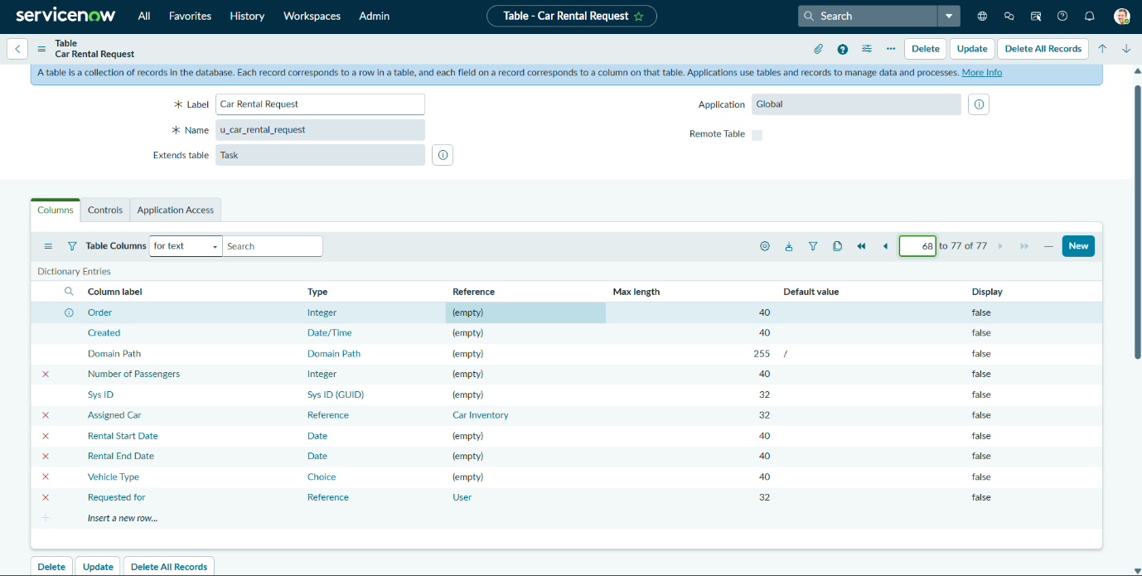

14. Custom Car Rental Request Structure
A custom structure can be used to represent project-specific car-rental information.
Important fields identified for the project include:
Field | Purpose
Requested For | Identifies the employee requesting the service
Rental Start Date | Starting date of the rental
Rental End Date | Ending date of the rental
Vehicle Type | Type/category of requested vehicle
Number of Passengers | Number of people requiring transportation
Assigned Car | Vehicle allocated for the request
These fields support the request and fulfillment side of the project.

15. Car Inventory Structure
A Car Inventory structure is used to represent available vehicles.
The purpose of this structure is to maintain information about the vehicles that can potentially be assigned to requests.
Suggested Information
Car Inventory
│
├── Car/Vehicle Name
├── Vehicle Type
├── Availability
├── Registration/Identifier
└── Other vehicle details
The exact fields can be extended depending on the organization's requirements.
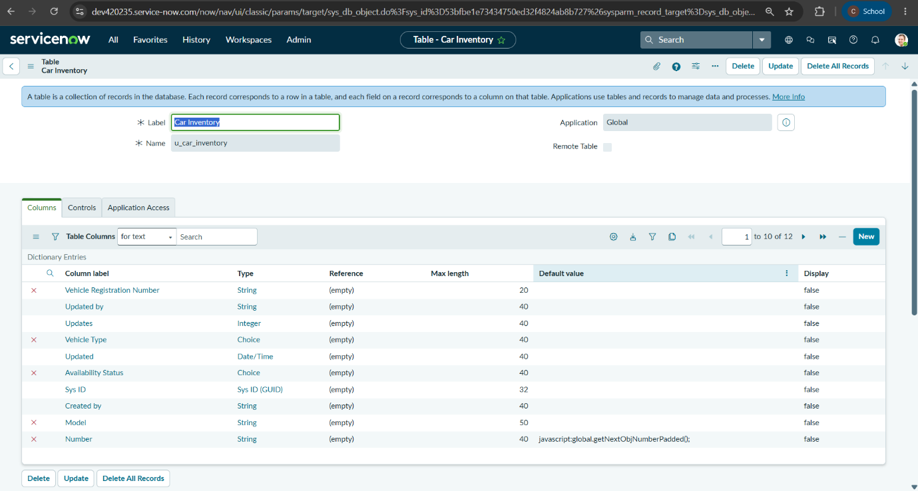

16. Vehicle Type
The vehicle inventory should support categories corresponding to the request form.
For example:
Vehicle Type | Description
Mini | Small vehicle
Sedan | Standard passenger vehicle
SUV | Larger passenger vehicle
This provides consistency between the request form and vehicle information.

17. Assigned Car
The Assigned Car field represents the vehicle selected during fulfillment.
Purpose
It connects the request to the vehicle allocated by the Transport Team.
Example:
Requested Car Type: SUV

Assigned Car:
Vehicle-001
The assigned-car information can then be used by fulfillment processing and request tracking.

18. Requested Item — RITM
The Requested Item (RITM) is an important part of the Service Catalog architecture.
When the requester submits the Car Rental Request catalog item, ServiceNow creates the corresponding request records.
The RITM becomes the primary catalog request record used during workflow processing.
Relationship
Catalog Item
↓
Request
↓
Requested Item (RITM)
↓
Workflow
↓
Approval
↓
Catalog Task

19. Approval Data
Approval information needs to be associated with the request.
The approval process must identify:
- Request being approved
- Approver
- Approval status
- Approval result
Possible approval results include:
Requested
↓
Approved
or
Requested
↓
Rejected
The workflow uses this result to determine whether fulfillment should continue.

20. Catalog Task Structure
The Catalog Task represents the actual fulfillment work.
For this project, the task is associated with the Transport Team.
Basic relationship
Car Rental RITM
↓
Approval
↓
Approved
↓
Catalog Task
↓
Transport Team
The Catalog Task allows the fulfillment team to work on the approved request independently of the requester-facing catalog form.

21. Assignment Group
The project uses the:
Transport Team
as the assignment group for fulfillment.
Purpose
The assignment group ensures that approved car-rental requests are routed to the appropriate team.
Instead of manually informing the Transport Team about every request, the workflow creates the fulfillment task and assigns it to the configured group.

22. CMDB Consideration
The ServiceNow Configuration Management Database (CMDB) can be used when vehicle information needs to be represented as configuration items or connected to organizational configuration data.
The project architecture considers the relationship between:
Car Rental Request
↓
Assigned Vehicle
↓
Vehicle / Inventory Information
This provides a foundation for future integration with a more detailed CMDB-based vehicle management solution.

23. Relationship Between Data Components
The major relationships are:
Service Catalog
↓
Catalog Item
Request/RITM
↓
/ | \
/ | \
Approval Workflow Variables
↓
Approved
↓
Catalog Task
↓
Transport Team
↓
Assigned Car

24. Data Flow
The data flow starts when the requester enters information in the catalog item.
Step 1
Requester enters:
Requested Date
Pickup Location
Drop Location
Duration
Car Type
Reason
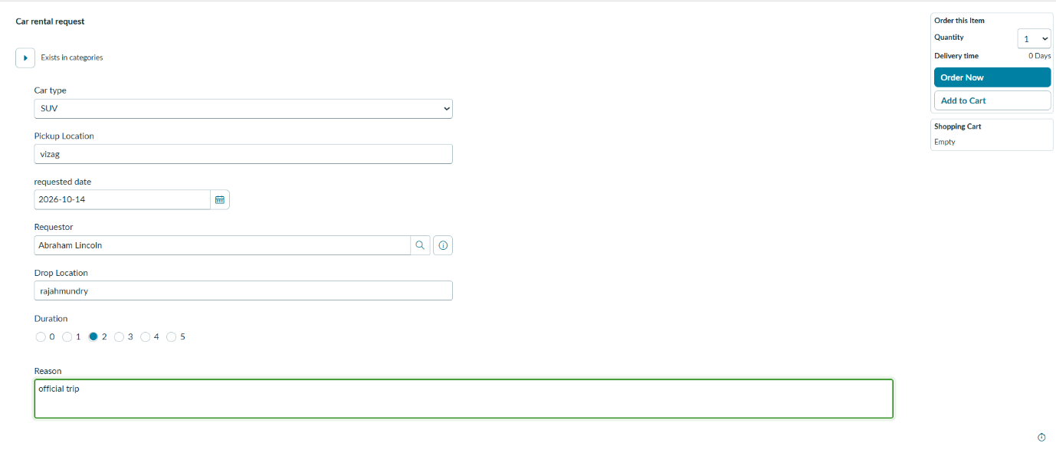
Step 2
ServiceNow stores the request information with the catalog request.
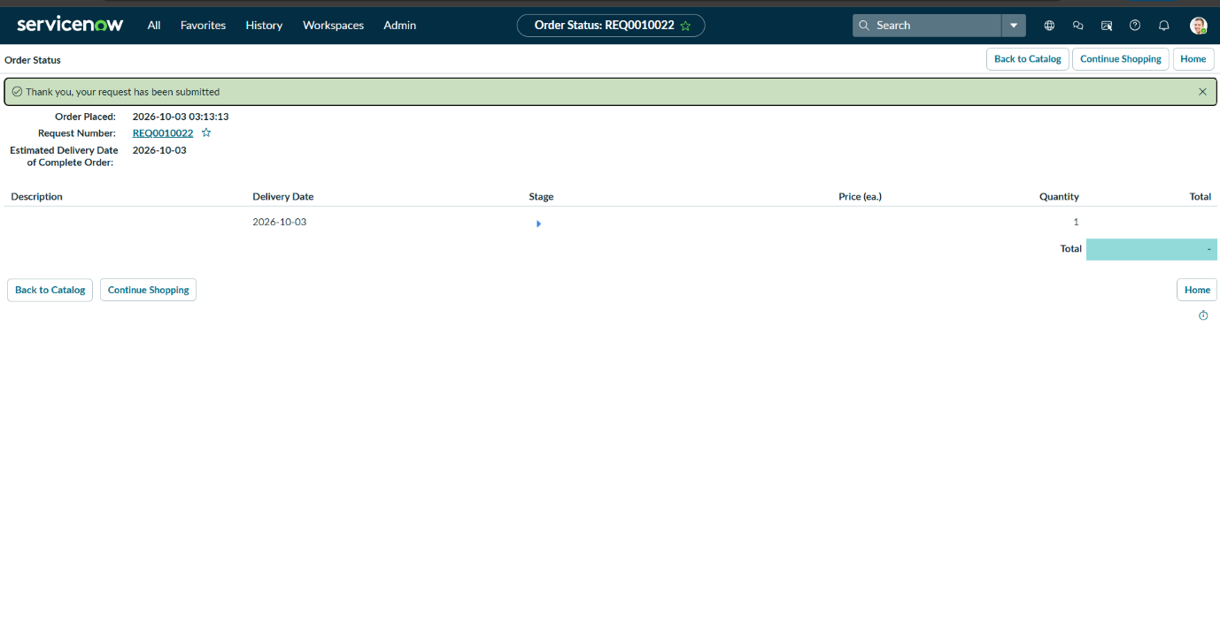
Step 3
A Requested Item is generated.
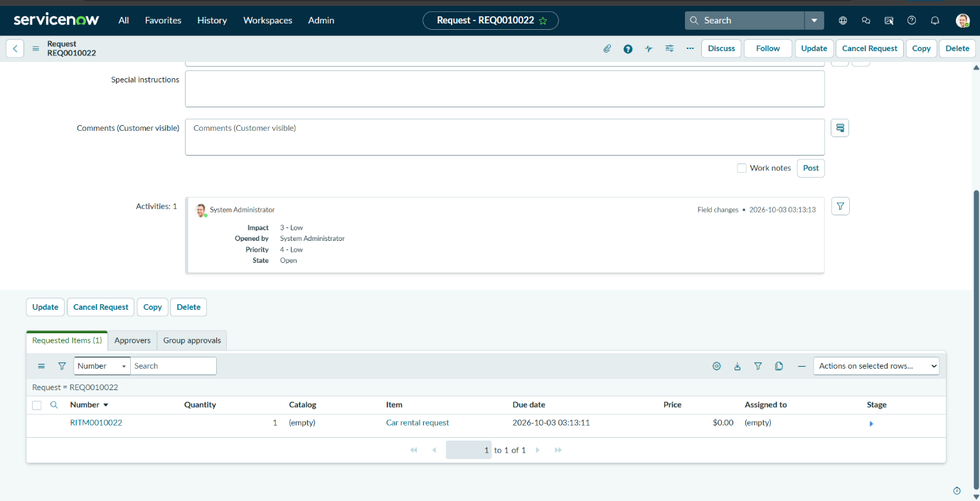
Step 4
The workflow uses the request information for approval and fulfillment.
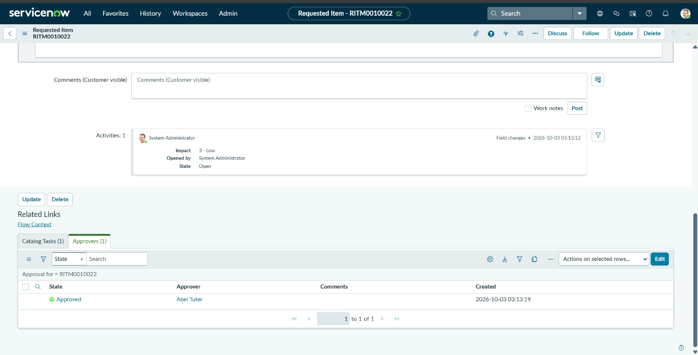
Step 5
After approval, a Catalog Task is created.
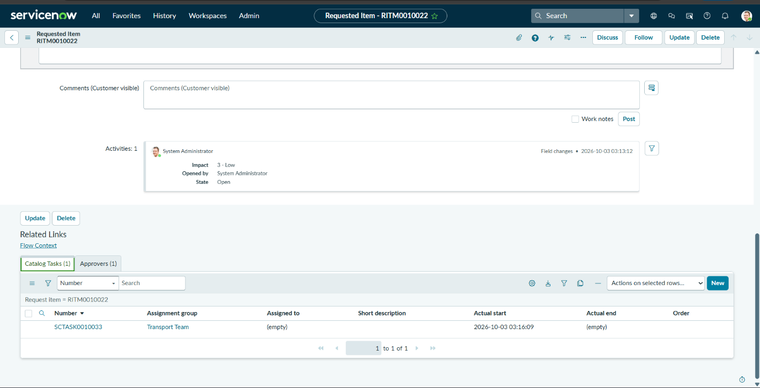
Step 6
The Transport Team processes the task.
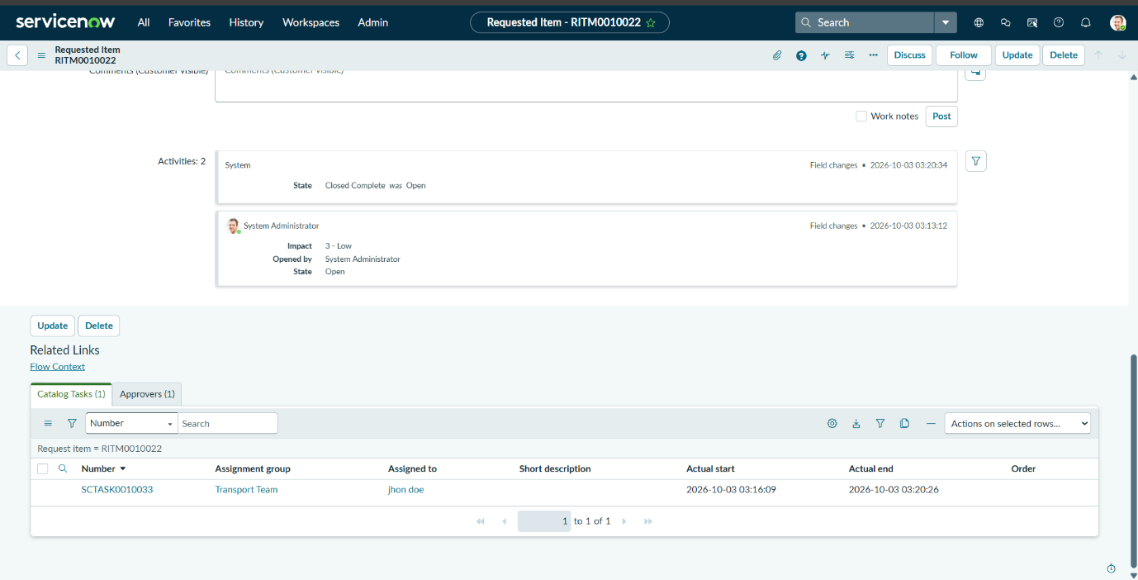
Step 7
Vehicle information such as the assigned car can be associated with the request.

25. Field Design
The project requires appropriate field types for different information.
Information | Suitable Type
Requested Date | Date
Rental Start Date | Date
Rental End Date | Date
Pickup Location | String / reference depending on implementation
Drop Location | String / reference depending on implementation
Duration | Integer/String depending on requirement
Car Type | Choice
Number of Passengers | Integer
Reason | String / multi-line text
Assigned Car | Reference / appropriate vehicle field
The exact field type can be adjusted according to the ServiceNow implementation and future integration requirements.

26. Choice Configuration
Choice fields are used where predefined values are required.
Car Type Choices
Mini
Sedan
SUV
Advantages:
- Consistent data
- Easier reporting
- Reduced invalid input
- Easier workflow conditions
- Easier filtering

27. Number of Passengers
The project architecture also identifies Number of Passengers as a useful request field.
Purpose
It provides information that can assist the Transport Team in selecting an appropriate vehicle.
For example:
Number of Passengers: 5
Car Type: SUV
The information can later be used for automated vehicle selection.

28. Update Set Configuration
An Update Set is used to manage configuration changes made during development.
The purpose is to collect related configuration changes into a controlled package.
Project Configuration Can Include
- Catalog item configuration
- Catalog variables
- Workflow changes
- Business rules
- Notifications
- Other configuration records
This helps maintain configuration consistency and supports movement of configuration between ServiceNow environments when required.

29. Update Set Process
The general process is:
Create Update Set
↓
Make Configuration Changes
↓
Changes Captured
↓
Review Update Set
↓
Complete Update Set
↓
Transfer/Move if Required
↓
Test in Target Environment

30. Data Validation Requirements
The architecture should ensure that invalid or incomplete information does not enter the fulfillment process.
Important validation areas include:
Required Fields
Required information must be provided before submission.
Choice Validation
Car Type must use configured choices.
Date Validation
Requested dates should contain valid date information.
Duration Validation
Duration should contain an acceptable value.
Fulfillment Validation
The request should not be considered completely fulfilled without the required fulfillment information.

31. Security Considerations
Access should be based on ServiceNow roles and responsibilities.
Requester
Should be able to:
- Create a request
- View their request
- Track the request
Manager
Should be able to:
- Review requests requiring approval
- Approve/reject requests
Transport Team
Should be able to:
- View assigned Catalog Tasks
- Process fulfillment
- Update task information
Administrator/Developer
Should be able to:
- Configure
- Test
- Maintain
- Troubleshoot

32. Configuration Naming
Consistent naming should be used for project components.
Example:
Catalog Item:
Car Rental Request

Assignment Group:
Transport Team

Variables:
Requested Date
Pickup Location
Drop Location
Duration
Car Type
Reason

Vehicle Types:
Mini
Sedan
SUV
Consistent naming makes the application easier to maintain.

33. Phase 2 Implementation Sequence
The implementation sequence is:
1. Review Phase 1 Requirements
↓
2. Identify Data Components
↓
3. Design Request Structure
↓
4. Define Catalog Variables
↓
5. Define Vehicle Information
↓
6. Configure Assignment Group
↓
7. Configure Supporting Fields
↓
8. Create/Use Update Set
↓
9. Validate Configuration
↓
10. Prepare for Catalog Development

34. Testing of Phase 2 Configuration
The following checks should be performed.
Test | Expected Result
Catalog item configuration | Catalog item exists correctly
Requested Date | Accepts valid date
Pickup Location | Accepts required location
Drop Location | Accepts destination
Duration | Stores rental duration
Car Type | Shows configured choices
Reason | Stores request purpose
RITM generation | RITM is created after submission
Assignment group | Transport Team is available
Vehicle information | Required vehicle fields are available
Update Set | Configuration changes are captured

35. Phase 2 Configuration Issues and Considerations
During development, several configuration areas require careful attention.
35.1 Field Design
Fields need appropriate data types and lengths so that they can store the required information correctly.
35.2 Choice Values
Vehicle categories must remain consistent between the request form and vehicle inventory.
35.3 Assignment Group
The Transport Team must be correctly configured so that fulfillment tasks can be routed to the intended team.
35.4 Request Relationships
The relationship between the catalog item, RITM, workflow, approval, and Catalog Task must be maintained correctly.
35.5 Update Set
Configuration changes should be captured in the appropriate Update Set to support controlled deployment.

36. Expected Output of Phase 2
At the end of Phase 2, the following should be available:
✓ Data architecture
✓ Catalog request structure
✓ Required variables
✓ Vehicle/car information structure
✓ Required fields
✓ Assignment group
✓ Request/RITM relationship
✓ Approval data structure
✓ Catalog Task structure
✓ Update Set
✓ Validation requirements

37. Phase 2 Deliverables
The major deliverables of Phase 2 are:
1. Data Architecture Document
Defines the structure of the application's data.
2. Field Definition
Documents the fields required for car-rental requests.
3. Catalog Variable Definition
Defines the variables used in the Car Rental Request catalog item.
4. Vehicle Inventory Design
Defines how car/vehicle information is represented.
5. Request Relationship Design
Documents relationships between:
Request → RITM → Approval → Catalog Task → Vehicle
6. Assignment Configuration
Defines the Transport Team assignment structure.
7. Update Set
Stores the relevant configuration changes.

38. Phase 2 Completion Summary
Phase 2 establishes the technical data foundation for the Car Rental Request Automation project.
The required ServiceNow data components were identified and structured around the complete request lifecycle.
The architecture can be summarized as:
CAR RENTAL REQUEST
↓
SERVICE CATALOG
↓
CATALOG ITEM
↓
REQUEST
↓
RITM
↓
_____________
| |
↓ ↓
APPROVAL VARIABLES
↓
APPROVED
↓
CATALOG TASK
↓
TRANSPORT TEAM
↓
ASSIGNED CAR
↓
COMPLETION

